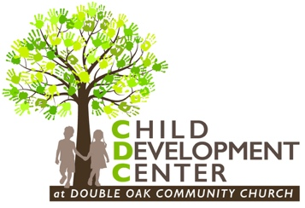
Double Oak
Child Development Center Registration
2019 – 2020

Child’s Name____________________________________________________________________

Name Child Goes By__________________________________ Boy_______ Girl________

Child’s Birthdate__________________________ Age on September 2, 2019___________

Allergies________________________________________________________________________

Parents’ Names________________________________________________________________

Family Email____________________________________________________________________

Phone: Mom_____________________________ Dad________________________________

Address________________________________________________________________________

City_______________________________ State___________ Zip____________________

PLEASE CHECK THE CLASS YOU ARE REGISTERING FOR: Age as of Sept 2, 2019
Classes meet as noted: MWF 9am-1pm or M-F 9am-1pm

_____17-24 Months MWF _____Four Year Olds MWF
_____Two Year Olds MWF _____Four Year Olds M-F
_____Three Year Olds MWF _____K5 Year Olds M-F

MONTHLY TUITION: MWF Class $200 M-F Class $280
YEARLY SUPPLY FEE: $150
There is a 10% tuition discount for each additional sibling in a family

FOR OFFICE ONLY:
Registration Fee $100 NON-REFUNDABLE Check #___________ Cash___________

